Menon
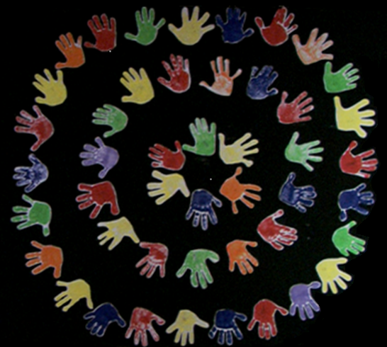

DOING PHILOSOPHY IN THE CLASSROOM

A Handbook for teachers

MENON is a Comenius - project of 11 European partners which aims to encourage teachers' professional growth by developing their dialogical sensitivity and skills through philosophical enquiry. As a consequence of this widening of teachers' perspectives and skills, the project is effectively aiming also to convert classrooms into communities of enquiry where dialogue is searched. Children will learn not only basic skills such as listening and responding, but also dispositions for lifelong learning and participation, such as curiosity, reasonableness and openness to others' perceptions and cultures.

This handbook is a tool-kit to be used when you organize a workshop for current or future teachers. Its basic goal is to offer those who are conducting the workshop some guidelines for doing so in such a way that they can accomplish the expected aims. In every Handbook the CD-rom disc is enclosed as a flexible and economical tool for teachers and teacher-trainers to save and gather further local materials of dialogue. This way, also, the cultural and national priorities and special needs of each country will be secured..

This project has been funded with support from the European Commission. This publication [communication] reflects the views only of the author, and the Commission cannot be held responsible for any use which may be made of the information contained therein.

MENON: Developing Dialogue through Philosophical Inquiry
Comenius 2.1 Action 226597-CP-1-2005-1-MT-COMENIUS-C21

Menon

Dialogue on Dialogue

A resource book for the
DEVELOPING DIALOGUE THROUGH DEMOCRATIC ENQUIRY
COURSE FOR TEACHERS

MENON is a Comenius - project of 11 European partners which aims to encourage teachers' professional growth by developing their dialogical sensitivity and skills through philosophical enquiry. As a consequence of this widening of teachers' perspectives and skills, the project is effectively aiming also to convert classrooms into communities of enquiry where dialogue is searched. Children will learn not only basic skills such as listening and responding, but also dispositions for lifelong learning and participation, such as curiosity, reasonableness and openness to others' perceptions and cultures.

The booklet 'Dialogue about Dialogue' is a collection of information and views about the practice of dialogue in educational contexts, designed to support the 30 hour course for EU teachers: 'Developing Dialogue Through Philosophical Enquiry'. It reflects the common experience of its authors: that philosophical questions/enquiry, broadly defined, provide a good stimulus for the practice of dialogue, and thereby for the ongoing development of specific skills or dispositions that are appropriately called 'dialogical'.

This project has been funded with support from the European Commission. This publication [communication] reflects the views only of the author, and the Commission cannot be held responsible for any use which may be made of the information contained therein.

MENON: Developing Dialogue through Philosophical Inquiry
Comenius 2.1 Action 226597-CP-1-2005-1-MT-COMENIUS-C21

